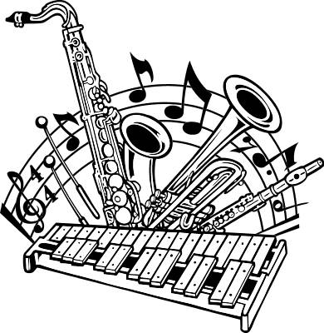
Stafford Middle School Band
Event Calendar
2023-2024

DATE TIME EVENT PLACE

Sept. 27 3:30-4:30 8th Grade Night Practice Stafford High School
(8th Graders Only)

Sept. 29 5:45pm 8th Grade Night Stafford High School
(8th Graders Only)

Dec. 2 TBA All-Region Auditions Stafford High School

Dec. 4 6:30pm Christmas Concert Stafford Centre

Jan. 27 TBA All-Region Clinic/Concert Needville H.S
(Selected Students)

March 26-28 TBA UIL Contest Brazosport HS

May 14 6:30 Spring Concert Stafford Centre

May 18 TBA Solo/Ensemble Stafford Band Hall

